KISS DP-558 Powersupply Modification

This page gives a step by step guide for modification of the KISS DP-558 Power Supply due to leaking/defective PSU capacitors.

The KISS DP-558 power supply has a construction error, that makes it fail, typically after beeing used 24/7 ranging from 1-3 years. The problem is proberly caused by the extensive heat that the unit generates combined low voltage capacitors (10 volt).

Mine failed after 2 years and 8 month beeing used 24/7.

Please observe, that making any modifications the the KISS DP-558 will void the warrenty, so proceed at own risk

KISS DP-558 is a high end harddisk recorder, with internet connection and FTP server and integrated online EPG (electronic Program Guide).

The DP-558 basically consist of a Powersupply unit, a main computer board, one DVD drive, one harddisk and a front unit

The harddisk is supplied by a +12 Volt (yellow) and +5 Volt (red). Ground is wired as black. When this type of error occures, both +12 volt and +5 volt linies drop in voltage. To make sure this fix is nessary for your type of error, check for the following symptoms:

Typical symptoms to look for:

• LCD Displays only: "KISS DVD"

• LCD Displays only: "BOOT ERR"

• Harddisk does not spin up when unit is powered on

• It is not possible to open DVD drive

• No reaction to remote control

• Display illumination is lower than usual

• Capacitors C19,C20,C15 of PSU may show leakage

• +12 volt and +5 volt supply to the KISS DP-558 harddisk is low (e.g 11 and 3 volt)

Step by step guide to KISS DP-558 Power Supply Modification/Fix

Step 1:
Remove mains power line, and wait at least 30 minutes before any repair is started.

Step 2:
Remove cover of the unit.

Step 3:
Located the Power Supply Module (PSU). PSU Type mus be: Achme AM561B
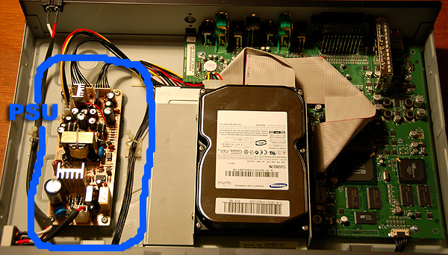

Step 4:
Disconnet the 4 power connectors from PSU module

Step 5:
Remove the 4 screws mounting the PSU to chassie

Step 6:
Located capacitor C19,C20 and C15
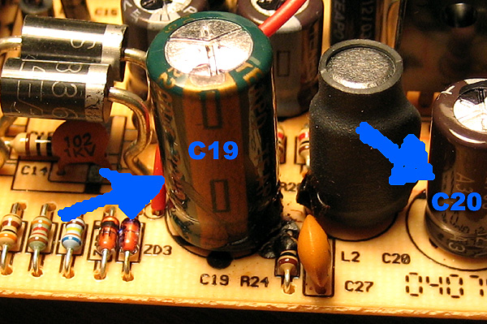

Step 7:
Remove the Capacitors C19,C20 and C15
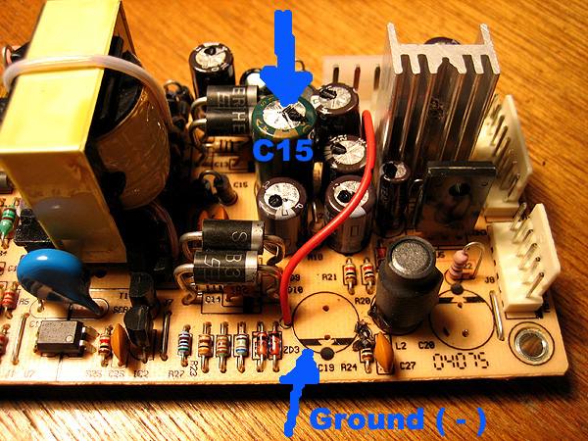

Step 6:
Replace the capacitors as followes (please observe polarity of capacitors +/-):
C15 | 1000 uF 16V 105C (Type: WGR Radial, Low impedance)
C19 | 2200 uF 16V 105C (Type: WGR Radial, Low impedance)
C20 | 1000 uF 16V 105C (Type: WGR Radial, Low impedance)

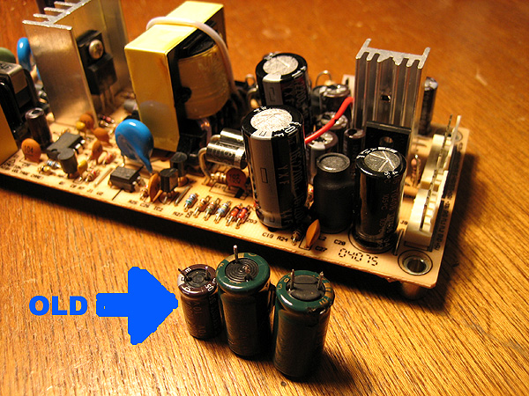

Step 9:
Reassemble the unit.

Final Note: it may be a good idea to replace other capacitors if they show sign of leakage. Please also note that a capacitor may be out of order even if it show not sign of leakage.

Links
- HiJack's Media Player Portal: KISS DP-558 Forum topic: Dead powersupply
- MPC Wiki web
- MPC Knowledge base
- MPC Knowledge Base: PSU issues
- PSU Circuit Diagram by woodstock

